PHASE 5 – KNOWLEDGE INTEGRATION
Incident Lifecycle Automation in ServiceNow
Implementation Documentation with ServiceNow Screenshot Evidence

1. Phase Objective
The objective of Phase 5 was to integrate Knowledge Management into the incident lifecycle so that support staff can use approved troubleshooting guidance while investigating the VPN issue. The knowledge article created for this scenario was KB0010001 – VPN Connection Troubleshooting.

2. Knowledge Article Created
Field | Configured Value
Article Number | KB0010001
Title / Short Description | VPN Connection Troubleshooting
Knowledge Base | IT
Version | v1.0
State | Approved
Valid To | 2100-01-01

3. Knowledge Content
The article documents the VPN problem, possible causes, resolution steps, and verification guidance. The troubleshooting procedure includes checking internet connectivity, restarting the VPN client, verifying credentials, clearing cached credentials when required, reconnecting to the corporate VPN, and escalating to the Network team if the issue continues.

4. Knowledge Article Approval and Reuse
KB0010001 was reviewed and approved before being used with the incident. From INC0010014, the Related Search Results area was changed to Knowledge Articles, the article was searched by title, and KB0010001 was attached. ServiceNow confirmed that the article details were added to the customer-visible Comments field.

5. Screenshot Evidence
The screenshot below provides the ServiceNow evidence for Phase 5 and shows the VPN troubleshooting Knowledge article used in the project.
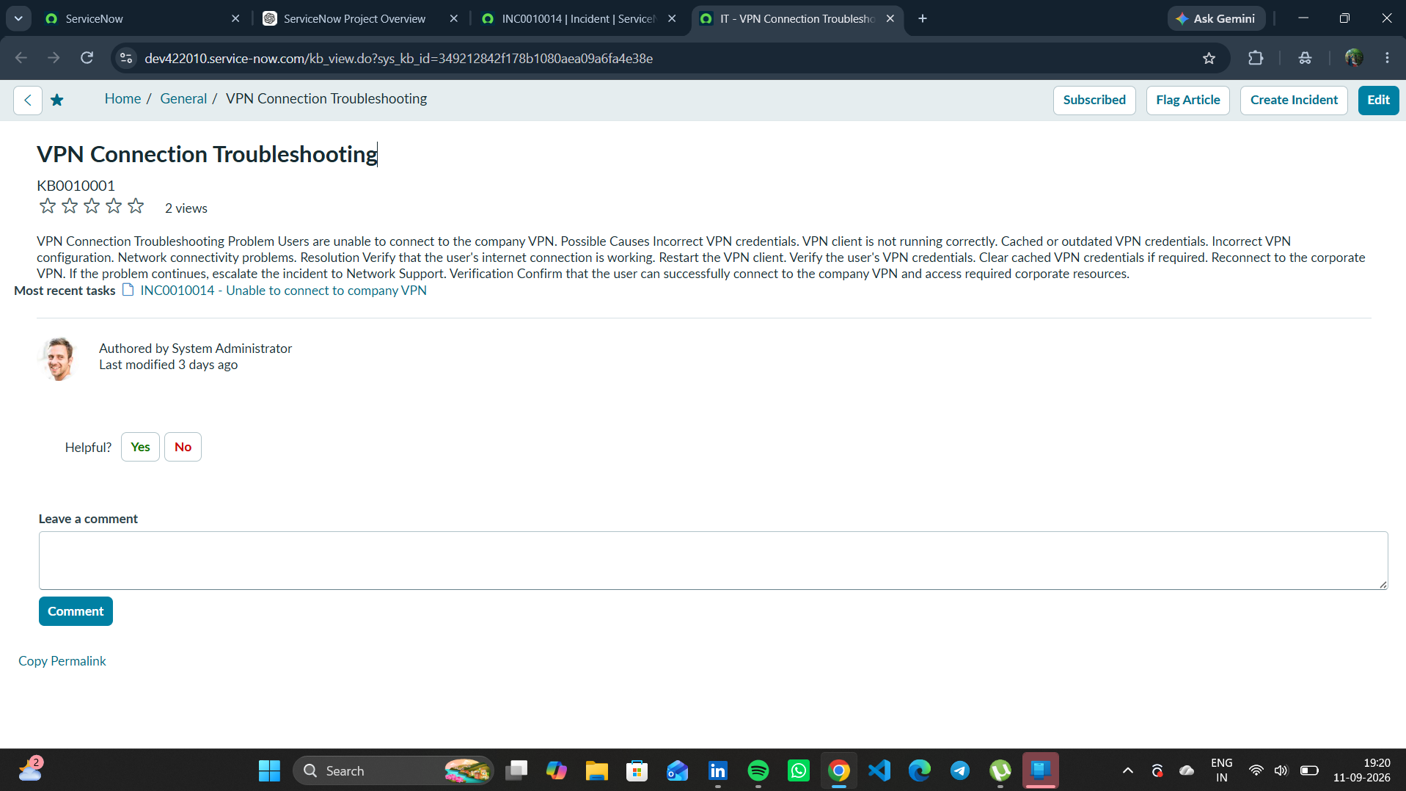
Figure 1. KB0010001 – VPN Connection Troubleshooting in ServiceNow.

6. Incident Integration
The approved article was attached to Incident INC0010014 as part of the troubleshooting workflow. This demonstrates how Incident Management can reuse documented Knowledge Management content rather than relying only on ad-hoc troubleshooting.

7. Phase 5 Outcome
- Knowledge article KB0010001 was created for the VPN issue.
- The article was approved and made available for support use.
- The article contains reusable troubleshooting and verification guidance.
- KB0010001 was searched from INC0010014 and attached to the incident.
- Knowledge Management was successfully incorporated into the incident lifecycle.
Status: COMPLETED

8. Phase 5 Evidence File
- 01_KB0010001_VPN_Connection_Troubleshooting.png

